DriverPass System Design Document

Prepared for DriverPass | CS 255 Project Two

UML Diagrams

UML Use Case Diagram
The use case diagram summarizes how customers, the secretary, drivers, the owner, and the IT officer use the DriverPass system.
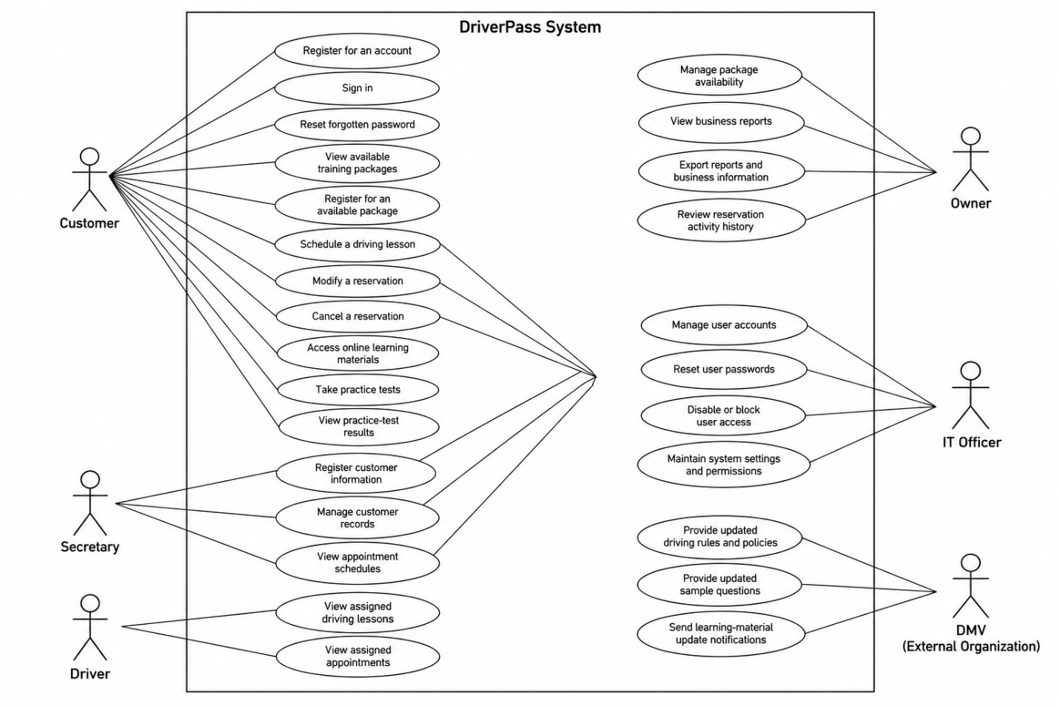

UML Activity Diagrams

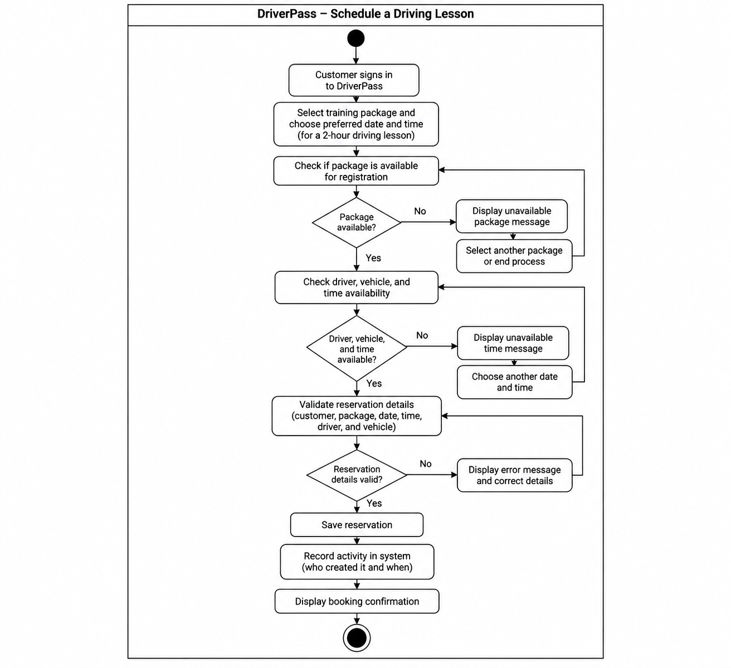
The two activity diagrams show (1) scheduling a driving lesson and (2) completing an online practice test.
Sequential diagram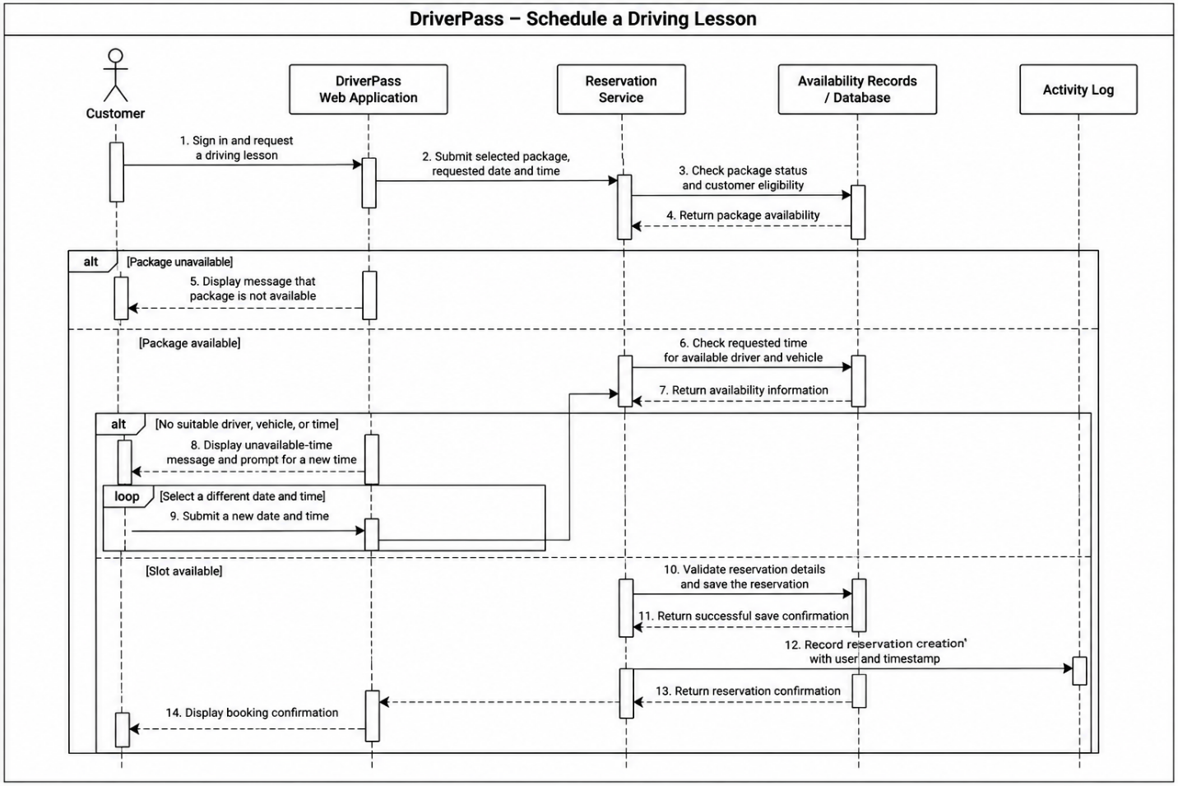
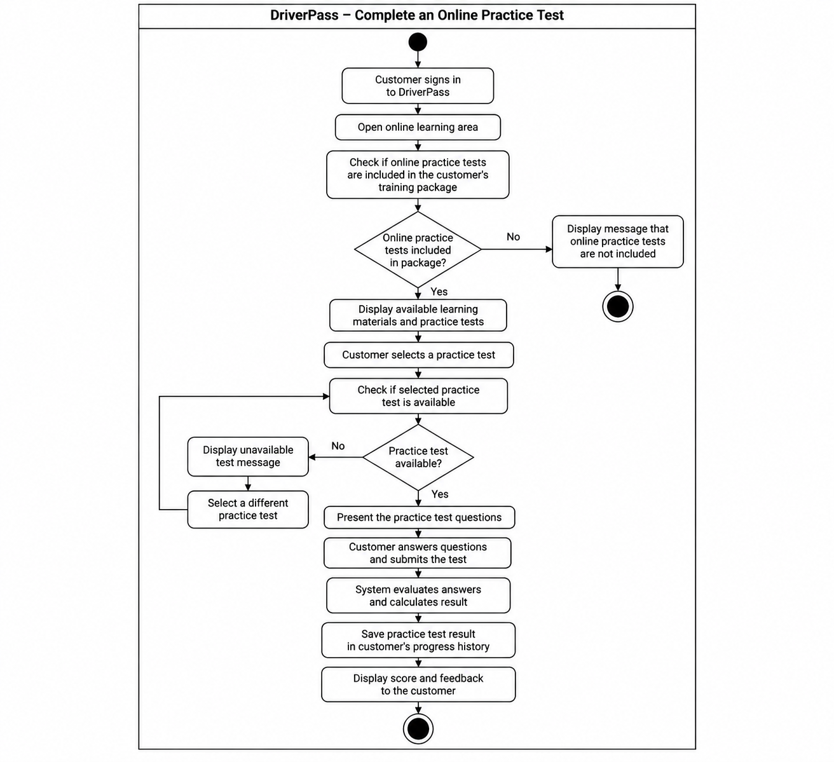

UML Sequence Diagram
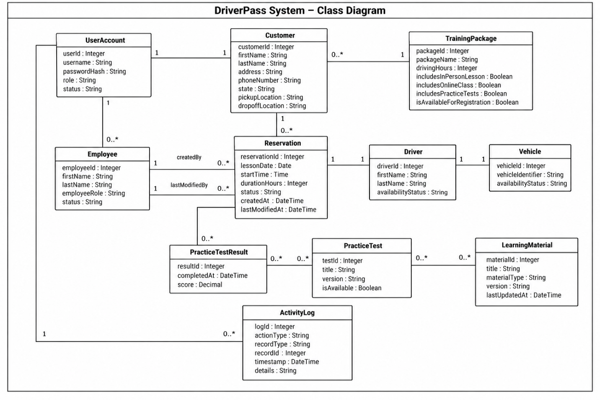
The sequence diagram shows the messages exchanged while a customer schedules a driving lesson.

UML Class Diagram
The class diagram organizes the main information the system needs to store and the relationships among those records.

Technical Requirements
Hardware Requirements
The DriverPass system should be accessible through desktop computers, laptops, tablets, and smartphones with a supported web browser and a reliable internet connection. The business will also require computers for administrative staff to manage customer records, reservations, and reports. The hosting environment must provide sufficient computing resources, database storage, and backup capacity to support the expected number of users and transactions.
Software Requirements
The proposed system requires a web application that supports customer registration, account authentication, training package selection, driving lesson scheduling, reservation management, and online practice tests for eligible customers. It also requires database software to store customer information, user accounts, training packages, reservations, driver and vehicle assignments, practice-test results, and activity records. The system should support report generation and export so the owner can review business information. Authorized staff must also be able to manage learning materials and package availability.
Tools and Infrastructure
The system should use a cloud-hosted environment so customers and employees can access it remotely without maintaining the application on individual computers. The infrastructure should include secure network connections, database hosting, automated backups, monitoring, and a recovery process for unexpected failures. Development and testing tools will be needed to build, validate, and maintain the application before updates are released to users. A relational database is a suitable proposed option because the system must maintain consistent relationships between customers, reservations, packages, drivers, and vehicles.
Security and Access Control
Each user should have an individual account, with permissions determined by their role. Customers should be able to manage their own reservations and access eligible learning resources, while the secretary manages customer records and appointments. The owner should have access to business reports, and the IT officer should be able to reset passwords, disable accounts, and maintain permissions. Passwords must be stored securely using password hashing, and information should be transmitted over encrypted connections. Reservation creation, modification, and cancellation should be recorded with the responsible user and timestamp to support accountability.
Reliability and Scheduling Accuracy
Before confirming a driving lesson, the system must check the requested two-hour time slot against the availability of the assigned driver and vehicle. It should prevent conflicting reservations and allow users to select another time when the requested slot is unavailable. Regular backups and monitoring should help protect business records and support recovery. Because the application depends on online services, users will need an internet connection to create or modify reservations and access online practice tests.
Maintenance and Limitations
The initial release should support the three agreed training packages and allow authorized staff to change their availability for new registrations. Adding new package types or major features may require assistance from the development team. Staff must review and maintain driving rules, policies, and sample questions when official materials are updated. The design should allow routine maintenance and updates without unnecessarily disrupting customers' access to the system.

